Important Dates  Please look at calendar dates given out in the school newsletter that may relate to your child. | Things to remember:  PE kits will be needed:  Acer: Thursdays  Cedar: Mondays  Hazel: Thursdays  Year 6 will need PE kits on Wednesdays too  Year 5 will need swimming stuff on Wednesdays | Our Topic  This half term we are learning all about World War 2  We will be learning about how the war begun, rationing, evacuation, the Blitz and the different roles men and women had. On the website you will find the knowledge organiser linked to this topic. Please share this with your child. An optional homework takeaway sheet has been sent home with your child.
English  There are 4 main purposes to writing: Writing to inform, writing to persuade, writing to entertain and writing to discuss. Your child will read a range of texts around these purposes and produce writing for each of the purposes. Below is a link to guidance notes for the four writing purposes in KS1 & 2.  https://michaelt1979.files.wordpress.com/2016/08/4-writing-purposes-guidance1.pdf  We have a whole class reading approach to reading in UKS2 where your child will read and experience a range of text types and be answering questions about them. | Homework  Please find below this table the link to our homework pledge.  http://woodley.suffolk.sch.uk/wp-content/uploads/2019/09/My-UKS2-Homework-Pledge.pdf | 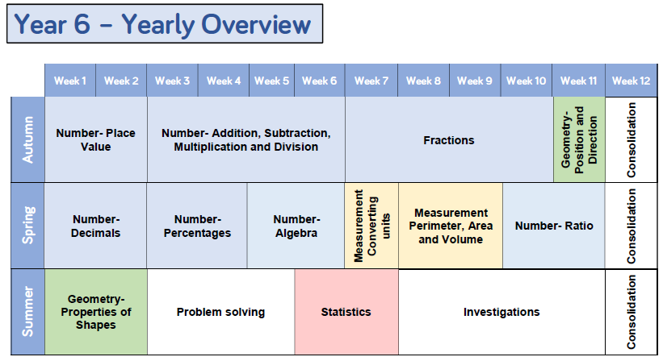  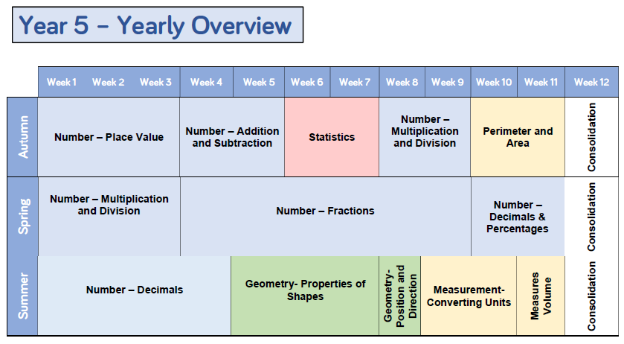  Maths

