

Primary English

Tips and Terminology

Subordinating Conjunctions

Subordinating conjunctions are used to start a subordinate clause. We use ‘A WHITE BUS’ to remember these words.

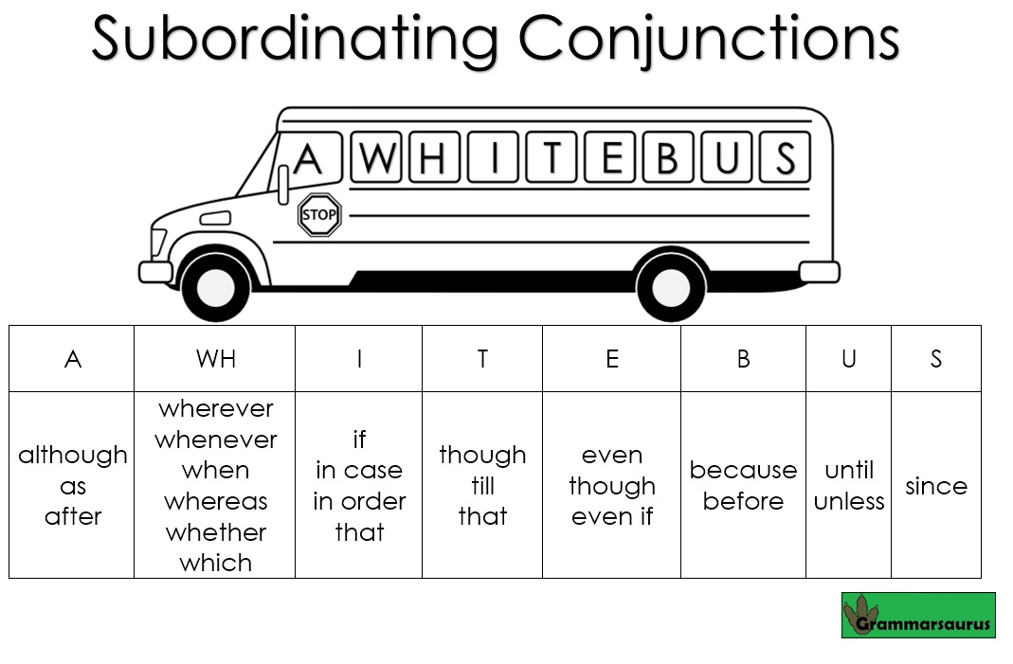

Co-ordinating Conjunctions

We use ‘FANBOYS’ to remember co-ordinating conjunctions. Co-ordinating conjunctions join two main clauses. You can replace a co-ordinating conjunction with a semi colon.

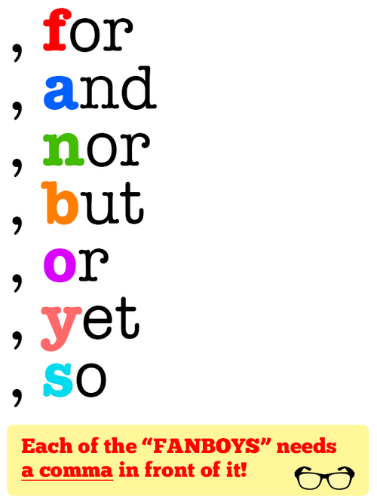

I can’t eat strawberries; they give me a rash.

Passive Voice

Passive voice helps us to vary our sentence types. Most sentences are written in the active voice (subject, verb then object). However, a passive voice sentence has a different order: object, verb and then the subject.

Active voice:

Miss Kay walked through the door.

Passive voice:

The door was walked through by Miss Kay.

This can make the object have more importance. Particularly, if we add adjectives:

The ambiguous door, with an intricate lock, was walked through by Miss Kay.

Subjunctive mood

The subjunctive mood indicates a wish or a desire. It is often unlike to come true.

The following songs are written in the subjunctive mood:

If I were a boy (Beyonce)

If I were a rich man (Fiddler on the Roof)

Embedded Relative Clauses

Embedded relative clauses are sandwiched into the middle of a main clause. They start with a relative pronoun (whom, who, where, that, which).

Amina, who is 27, is a teacher.

My school, which is located in England, is brilliant.

Modal Verbs

Modal verbs indicate how possible or certain something is.

The following words are modal verbs:

Would

Could

Should

Might

May

Ought to

Must

Subordinate Clauses

Subordinating conjunctions are used to start a subordinate clause. A subordinate clause can be at the start or the end of a sentence. It will be dependent on the main clause.

Examples:

Although I was tired, I still ran to work.

I still ran to work although I was tired.

Key:

Subordinate clause

Main clause

Subordinating conjunction

How can you use punctuation to avoid ambiguity?

If something is ambiguous, it has more than one interpretation. For example:

Let’s eat Grandma.

Let’s eat, Grandma.

How many shoes do you have!

How many shoes do you have?

Man eating shark.

Man-eating shark.

Punctuation can be used to avoid ambiguity.

Figurative Language

(Similes, metaphors, personification, alliteration and onomatopoeia).

Similes- compare something to something else. They use the word ‘as’ or ‘like. Example:

She swam like a fish.

Metaphors- a figure of speech in which a word or phrase is applied to an object or action to which it is not literally applicable**. Example:**

His house is his castle.

Personification- the attribution of a personal nature or human characteristics to something non-human. Example:

The leaves waved in the wind.

Alliteration- the occurrence of the same letter or sound at the beginning of adjacent or closely connected words. Example:

Silly Susan swept.

Onomatopoeia- the formation of a word from a sound associated with what is named. Examples:

Boom, bang, hiss, crash

Fronted Adverbial Phrases

Fronted adverbials are words or phrases at the beginning of a sentence, used to describe the action that follows. A comma is usually used after an adverbial.

Examples:

Unfortunately,

Quickly,

Without warning,

In the blink of an eye,

Colons

You can describe something, use a colon and then give details. For example:

The vampire is a dreadful creature : it kills by sucking all the blood from its victims.

Snails are slow: they take hours to move the shortest of distances.

Imagine colon sentences

These sentences begin with the word ‘Imagine’ and then describe 3 things about a place, time or person. After the 3rd description there is a : followed by a statement saying there is such a time, place, person.

Examples:

Imagine a time when people were not afraid, when life was much simpler, when everyone helped each other: this is the story of that time.

Imagine a place where the sun always shines, where wars never happen, where no-one ever dies: in the Adromeda 5 system there is such a planet.

Apostrophes

(For contractions and omission)

Apostrophes are used for contractions where letters have been omitted. Examples:

Do not= don’t

Can not = can’t

It is= it’s

They are also used to show possession:

The parents’ evening was running late. (The apostrophe comes after the s because more than one parent will attend the meeting).

The boys’ beds were broken. (The apostrophe comes after the ‘s’ because there is more than one boy. This avoids ambiguity).

The girl’s chair was red. (The apostrophe comes before the ‘s’ because there is only one girl. This avoids ambiguity).

The children’s toys were stolen. (When the word is already plural, the apostrophe comes before the ‘s’ because there is no ambiguity.)

Antonyms

Antonyms are opposites. For example:

Sister & brother

Boiling & freezing

Obese & emaciated

Dependent & independent

Synonyms

Synonyms are words or phrases that are the same or similar. For example:

Hot & boiling

Freezing & cold

You can also say something is synonymous because it is similar/the same. Example:

His deeds had made his name synonymous with victory

Parenthesis

Parenthesis refers to additional information in a sentence. You can show parenthesis with brackets, commas or dashes. When you remove the parenthesis, the sentence should still make sense.

My dog (Barney) is a labradoodle.

My sister- the one who lives in Austria- is visiting us soon.

Darwin, a scientist, discovered the theory of Evolution.

Prepositions

There are prepositions of location, direction and time. Here are some examples:

Under

Over

In

In front of

Next to

Behind

You can make prepositional phrases with these words, which can be used to start a sentence:

In 1992, I was born.

They can also be used at the end of a sentence:

I have lost my keys but I think they are under my chair.

Homophones, homonyms and homographs

Homophones are words that are spelt differently but sound the same.

Examples: their/there/they’re, blew/blue, sea/see

Homographs are written the same but are pronounced differently.

Examples: read/read

Homonyms sound the same and are pronounced the same.

Examples: bat/bat

Nouns

(collective, compound, abstract, common, proper, pronouns)

Collective

Flamboyance of flamingos, gaggle of geese, herd of cows

Compound

Toothbrush, bookshop, armchair

Abstract

Bravery, love, hate

Common

Chair, table, school

Proper

Wood Ley Primary School, Jasmine, Suffolk, Stowmarket

Proper nouns need capital letters.

Pronouns replace nouns

His

Her

We

They

Mine

Pronouns avoid repetition in writing.

Determiners

Determiners are positioned before a noun to make a noun phrase.

However, adjectives are not determiners.

There are 4 types:

Articles

The

An

A

Demonstratives

This

That

those

these

Possessives

Her

Her

Quantifiers

Many

some

Tenses

|  |  |  |  |  |
| --- | --- | --- | --- | --- |
|  | Simple | progressive | Perfect | Perfect progressive |
| Present | I eat. | I am eating. | I have eaten. | I have been eating |
| Past | I ate. | I was eating. | I had eaten. | I had been eating. |
| Future | I will eat. | I will be eating. | I will have eaten. | I will have been eating. |

Common mistakes at our school:

1. A lot= 2 words. ‘alot’ is not a word.
2. Your = possessive (your bag, your shoes, your house)

You’re = contraction (whenever you could say ‘you are’ in a sentence, you can use ‘you’re-you’re awesome, you’re happy).

1. Their= possessive (their bag, their shoes, their toy)

There= prepositional- go over there!

They’re= contraction for ‘they are’ – they’re cool/ they’re timid

1. Its- possessive (its collar)

It’s – contraction (it is- it’s my birthday)

1. Brought- to bring something

Bought- to buy something

1. whose-

who’s – contraction for ‘who is’ – who’s coming to my party?

1. Much/many –use many for plurals and people, use much for singular nouns
2. Them/those. Use them when referring to people & those when referring to objects.

Additional important vocabulary:

Juxtaposition: Place or deal with close together for contrasting effect. Example:

"black-and-white photos of slums were starkly juxtaposed with colour images.

Mnemonic: Helps you to remember key patterns or spellings. Such as: my very easy method just speeds up naming planets (Mercury, Venus, Earth, Mars, Jupiter, Saturn, Uranus, Neptune)

Acronym: Example: SEND (special educational needs and disabilities).

Plural: More than one. Examples: boys, sheep, toys, schools and necklaces.

Prefix: the letters that can be added to the start of a root word. Examples: unfortunately, producing and happily .

Suffix: the letters that can be added to the end a root word. Examples: Unfortunate and reproduce.

Vowel- A,E,I,O,U. Every other letter is a consonant.

Superlative: Examples: big, bigger, biggest

Cute, cuter, cutest.

Oxymoron: When two words contradict for effect

Examples: a new classic, modern history, a true myth, the loudest whisper.

Adjective: A word that modifies a noun to add detail. Examples: awesome and ancient.

Adverbs: An adverb describes a verb, an adverb or another verb. Examples: quickly, slowly and enthusiastically.

Semi Colons

A semicolon can be used between two closely related independent clauses, provided they are not already joined by a coordinating conjunction. Semicolons can also be used in place of commas to separate items in a list, particularly when the elements of that list contain commas.

Examples:

I recommend the new Italian restaurant; the prices on the menu are very reasonable.

I liked the book; it was a pleasure to read.

I need tomatoes; half a pound of butter; a kilo of pasta and a jar of olives.

Cheat by learning the ‘some; others’ sentence type:

Some people like sweets; others prefer chocolate.

Some people like sweets and others prefer chocolate.

Noun phrases

Determiner, adjective, noun.

For example:

The smart teacher.

A magnanimous mission.

The loud students.

Command

Pick up your bag.

Statement

I am 27 years old.

Question

How are you?

Exclamation

You have a lot of shoes!

Key questions for extending children’s writing

1. Can you think of a synonym to replace the word ______?
2. How could you vary your sentence openers to avoid repetition? Fronted adverbial/ prepositional phrase/ subordinate clause
3. Can you find a homophone that you have used incorrectly?
4. Have you used synonyms to avoid repetition?
5. Have you considered replacing some of your co-ordinating conjunctions with semi colons?
6. How could you up-level your vocabulary?
7. Have you heard any spelling mnemonics to help you with your spellings? (rhythm- rhythm helps your two hips move)
8. Could you try to write on the line?
9. This sentence sounds ambiguous. Can you add punctuation to clarify your meaning?

How to encourage lovely handwriting:

1. Provide pencil grips or an alternative pen/pencil to write with.
2. Encourage the child to write on the line.
3. Correct the child’s posture. Make sure their feet are flat on the floor.
4. Ask them to form their letters the same size.
5. Write a sentence for them and encourage them to copy it neatly.
6. Provide a piece of paper which has the alphabet neatly recorded.
7. Highlight the lines of the book to encourage the child to form the letters in the correct place.
8. Provide a handwriting book for home.

Inverted Commas

“”

Speech marks should be called inverted commas in KS2. They surround what has been said.

A new line should be started for each new speaker.

Synonyms for said should be encouraged.

Example:

“You’ve left your bag behind”, shouted the teacher.

Phonics

**Blending**

Blending involves merging the sounds in a word together in order to pronounce it. This is important for reading.

**Consonant**

The letters in the alphabet (apart from the vowels which are: a, e, i, o, u)

Consonant digraph

A digraph is made up of two consonants (sh)

**CVC**

An abbreviation for consonant- vowel- consonant. (Cat)

**Digraph**

A grapheme made up of two letters that makes one sound (sh in fish)

Grapheme

A grapheme is a way of writing down a phoneme. A phoneme can be one letter (s), two letters (ir), three letters (igh) or four (ough).

**Segmenting**

Breaking up a word so you can hear the sounds.

**Split digraph**

The digraph that is split between a consonant (a-e in make)

A split digraph usually changes the sound of the first vowel. (hug and huge)

**Trigraph**

A grapheme made up of three letters that make one sound (igh in high)

Spelling and Phonics

**Teaching the Rule**

Many spellings have set rules which need to be learned (outlined in the half termly spelling overviews). When teaching these rules, teachers also show children any exceptions.

**Etymology & Morphology**

Morphology is the study of the structure of words. Morphemes are the smallest unit of meaning in a word and words can be broken down into these root words, prefixes and suffixes. Children identify these with different coloured pens. Studying morphology helps children to identify word families. These can be shown in a range of ways:

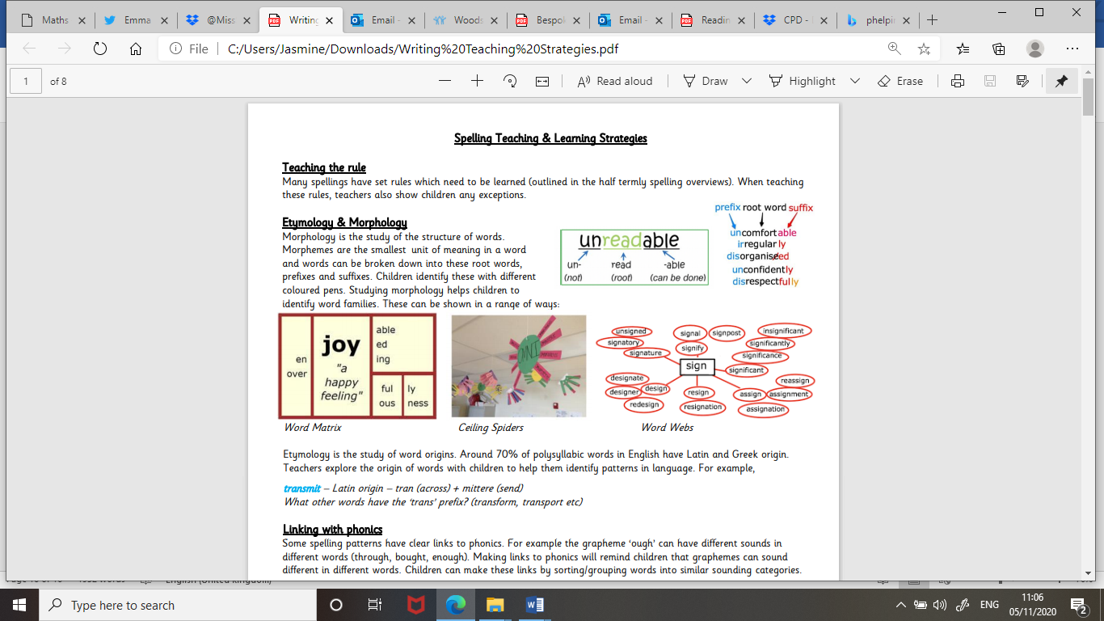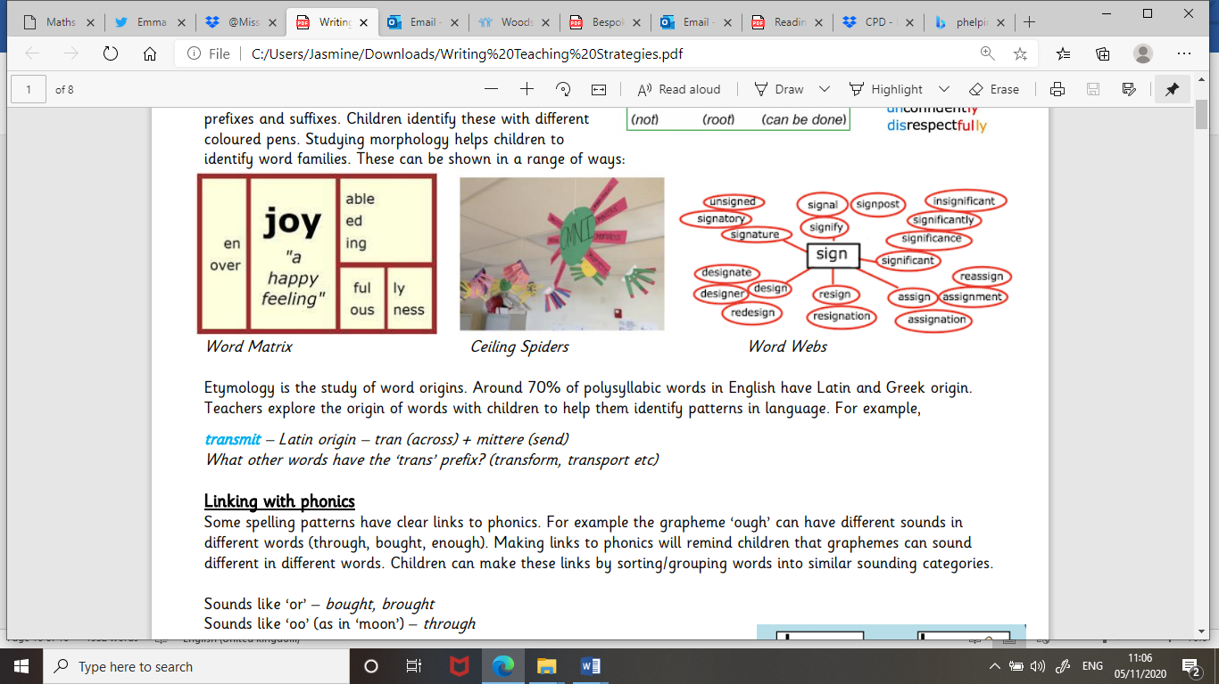

Etymology is the study of word origins. Around 70% of polysyllabic words in English have Latin and Greek origin. Teachers explore the origin of words with children to help them identify patterns in language. For example, transmit – Latin origin – tran (across) + mittere (send) What other words have the ‘trans’ prefix? (transform, transport etc)

**Linking with phonics**

Some spelling patterns have clear links to phonics. For example the grapheme ‘ough’ can have different sounds in different words (through, bought, enough). Making links to phonics will remind children that graphemes can sound different in different words. Children can make these links by sorting/grouping words into similar sounding categories. Sounds like ‘or’ – bought, brought Sounds like ‘oo’ (as in ‘moon’) – through

**Visual Representations**

Creating visual images to accompany words can aid memory. This strategy works particularly well with homophones, where teachers show children how to learn the difference between them pictorially.

Mnemonics

Some longer words can be learnt through creating a mnemonic to aid memory.