**Geography: Africa**

* In this unit, the children will: l locate Africa on a world map and recognise that the African continent is made up of 54 countries. They will use compass-direction clues to identify and locate each country, l learn that Africa can be split into five different regions and identify which region various African countries are in. They will then identify Nigeria as being a country in western Africa, before finding out about the human and physical features of Nigeria, identify the seven countries of northern Africa on a map, before exploring some general features of this area. They will then explore Morocco in more detail, looking at both human and physical features of the country, identify the nine countries of central Africa and features common to this region, including the equatorial climate.
* They will then explore the Central African Republic, including exploring how and why a country rich in resources can be so poor, identify the 18 countries of eastern Africa before looking at some photos of Tanzania to explore what this country is like. They will consider what can and can’t be learnt about a place from photos, before finding out more about the human and physical features of Tanzania, identify the five countries of southern Africa before looking in more detail at South Africa, including a brief overview of apartheid.
* They will then focus on the physical features of South Africa, exploring the nine different biomes and South Africa’s biodiversity, and they will consolidate their learning about Africa firstly by answering some ‘true or false’ statements, giving reasons for their answers. They will recap the countries they have learnt about before having the opportunity to research another African country independently.

**Science: Human Development**

In this unit, the children will: learn about, then order, the main stages in the life cycle of humans. They will then consider and describe factors which may affect the rate of growth in humans, sexual reproduction, fertilisation and pregnancy for humans. They may then compare the gestation periods of humans with other animals, changes during infancy and childhood, then consider the needs of children, and how these change over time as they develop, the roles of some hormones in the body, and how they affect changes in boys and girls at the start of puberty. They will also identify and describe or label changes that occur inside and outside the body, later changes during puberty and adolescence, including sperm production and menstruation. They will then consider and describe ways in which children can stay fit and healthy during puberty, and some changes in the body that occur during adulthood and old age. They then either describe ways in which they may change as they get older, or discuss some problems associated with stereotypical views regarding the elderly.

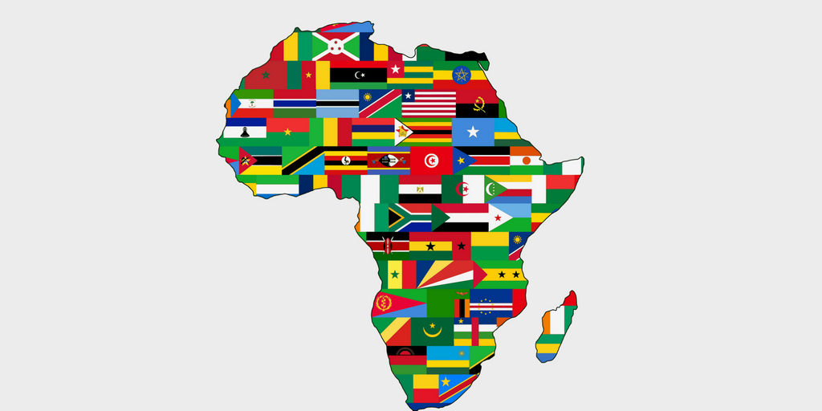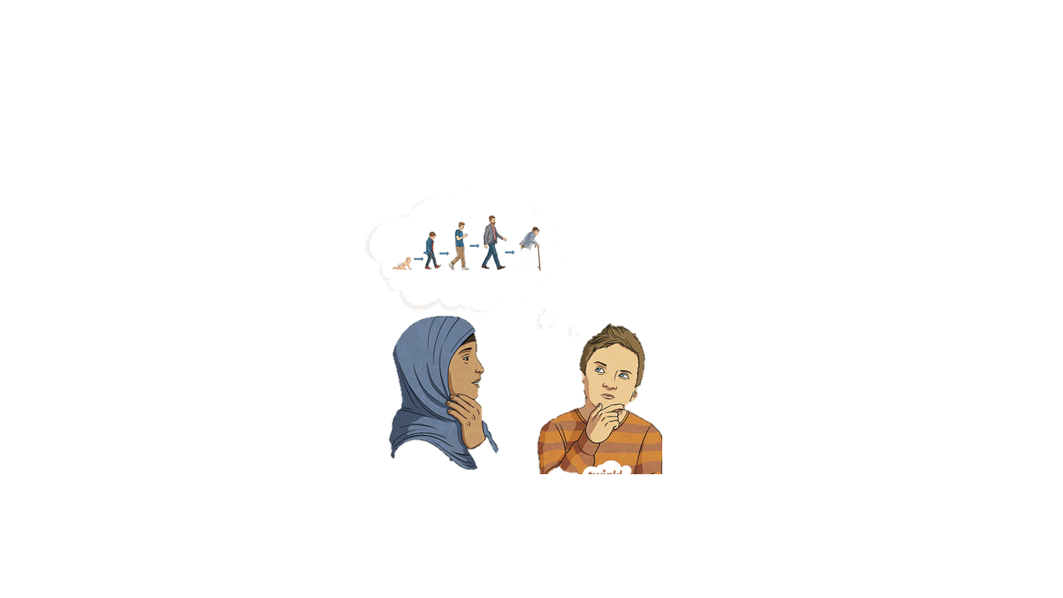

**See bespoke pathways for Maths and English**

**Art/DT: Twin 7-7**

The children will be exploring artwork by the Nigerian artist Twins Seven Seven. The children will use a range of mediums including oil pastels and paint. Moroccan slippers will be made by the children which will allow them to develop their sewing skills. The children will also be able to create a plant pot from recycled materials.

**Landscapes**

The children will be drawing and painting different natural landscapes. They will be looking for art in natural landscapes around Africa.

**Music: Year 5/6 Production**

The children will have the opportunity to have a part in the school play. All of the children will enjoy learning and performing the songs.

**PSHE: Changing Me (RSE)**

In this unit, the children will be aware of their own self-image and how their body image fits into that, explain how a girl’s body changes during puberty and understand the importance of looking after yourself physically and emotionally, describe how boys’ and girls’ bodies change during puberty, understand that sexual intercourse can lead to conception and that is how babies are usually made, understand that sometimes people need IVF to help them have a baby, identify what they are looking forward to about becoming a teenager and understand this brings growing responsibilities (age of consent), and they will identify what they are looking forward to when they move to their next class.

**French: Time Travelling**

In this unit, the children will broaden their vocabulary and develop their ability to understand new words that are introduced into familiar material; speak in sentences, using familiar vocabulary, phrases and basic language structures in the context of counting into thousands. To understand basic grammar appropriate to the language being studied, how to apply these, for instance, to build sentences; and how these differ from or are similar to English; read carefully and show understanding of words, phrases and simple writing in the context of talking about age. To listen attentively to spoken language and show understanding by joining in and responding in the context of French historical events. To listen attentively to spoken language and show understanding by joining in and responding in the context of French historical events. To understand basic grammar appropriate to the language being studied, how to apply these, for instance, to build sentences; and how these differ from or are similar to English in the context of discussing when you were born. To understand basic grammar appropriate to the language being studied, how to apply these, for instance, to build sentences; and how these differ from or are similar to English in the context of discussing people’s lives.

**PE: Basketball**

The children will develop:

* protective dribbling against an opponent
* moving into and create space to support a teammate
* choosing when to pass and when to dribble
* tracking an opponent and use defensive techniques to win the ball
* performing a set shot and a jump shot

**Hockey**

The children will develop:

* dribbling to beat a defender
* sending the ball using a push pass
* receiving the ball with control
* moving into space to support a teammate
* using an open stick (block) tackle and jab tackle to gain possession of the ball

**Year 5**

**Summer 2**

**RE: Buddhism – Journey of Life and Death**

The children will find out who Buddha was and why he is important to Buddhists today. To learn about the Four Noble Truths and the Eightfold Path.

They will explain how believers have expressed their religious beliefs (ideas, feelings, etc) in a range of styles and words, and suggest reasons for this.

They will use the correct religious words to describe practices and experiences which may be involved in being a Buddhist; express religious beliefs (ideas, feelings, etc) in a range of styles and words used by believers, and they will explain what they are trying to convey ask questions about the diversity of groups people belong to, and suggest answers which refer to people’s heritage, background, choices or beliefs

Symbolism and Religious Expression

How did Buddha teach his followers to find ENLIGHTENMENT?

**Computing: Programming 1 – Music**

In this unit, the children will:

* Iterate ideas, testing and changing throughout the lesson. Explain what the basic commands do.
* Explain how their program links to the theme. Include a loop in their work. Correct their own simple mistakes.
* Explain their scene in the story. Link musical concepts to their scene. Include a repeat and explain its function to enhance music.
* Code a piece of music that combines a variety of structures. Use loops in their programming.
* Recognise that programming music is a way to apply their skills