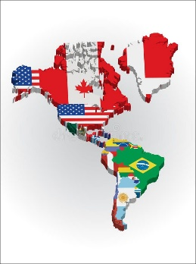

**Science: North and South America: Skills Based Scientific Enquiry**

Within this unit, the students will plan different types of scientific enquiries to answer questions including recognising and controlling variables where necessary. They will take measures with accuracy and precision. They will make pneumatic-powered blow darts inspired by Amazonian tribes, boats powered by surfactants, explore how to make water safe enough to drink and investigate appropriate clothing which will not absorb additional heat in the sun.

**French: This is France (continued)**

This ‘This is France!’ unit will teach the students key vocabulary related to France and, in particular, Paris. The class will learn specific vocabulary to describe France's neighbours and positions/distances of a variety of cities. They will learn the French names for famous French landmarks and how to describe what people do when they visit Paris. Also, one lesson focuses on famous French people and children will learn the French names for the areas that they were/are famous for. They will also learn key phrases connected to the themes which run through this unit.

**Geography: South America**

The children will be exploring the continent of South America. By the end of the unit, they will be able to:

* Identify the position and significance of latitude, longitude, Equator, Northern Hemisphere, Southern Hemisphere, the Tropics of Cancer and Capricorn, Arctic and Antarctic Circle, the Prime/Greenwich Meridian and time zones (including day and night)
* Describe and understand key aspects of physical geography, including: climate zones, biomes and vegetation belts, rivers, mountains, volcanoes and earthquakes, and the water cycle
* Describe and understand key aspects of human geography, including: types of settlement and land use, economic activity including trade links, and the distribution of natural resources including energy, food, minerals and water

**Year 6**

**Summer 1**

**Computing: Data Handling**

Within this data handling unit, the students will understand why barcodes and QR codes were created.They willcreate (and scan) their own QR code using a QR code generator website.The class will be able toexplain how infrared can be used to transmit a Boolean type signal.Explain how RFID works, recall a use of RFID chips, and type formulas into spreadsheets. Take real-time data and enter it effectively into a spreadsheet. They willpresent the data collected as an answer to a question. Recognising the value of analysing real-time data. Analyse and evaluate transport data and consider how this provides a useful service to commuters.

**Music: Samba: Traditional Brazilian Music**

The class will be introduced to Brazil's most well-known type of music. The children will learn **rhythms and beats of samba**, bringing this important part of Brazilian culture into the classroom.  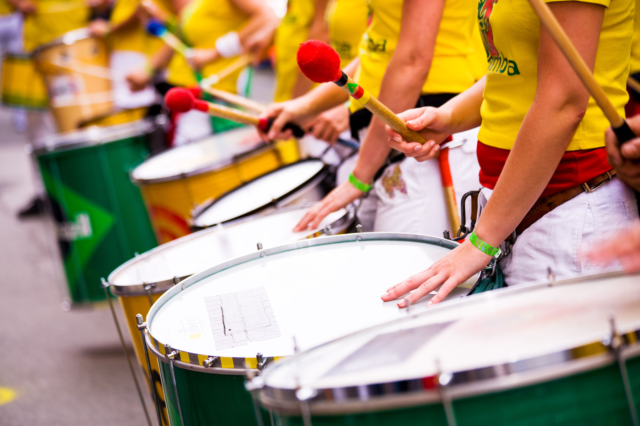

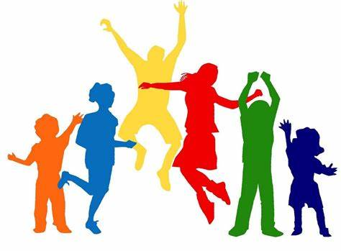

**PSHE: Relationships**

In this unit the children will be learning in more detail about Mental Health. The unit overs identifying worries and finding sources of support. Children will learn about managing feelings and discover how behaviours are driven by feelings.

The unit covers love and loss, power and control, assertiveness and taking on responsibility for technology safety.

**See bespoke pathways for Maths and English**

**ART and DT: N&S American themed artwork**

Cardboard Amazonian creatures will be created- these are inspired by Darrel Wakeman’s work and will be exploring the work of Frida Kahlo.

**RE: Encountering Judaism through worship, pilgrimage and sacred places**

Within this Judaism unit, the students will focus on one area of study: Holinessis also known as KEDUSHAH in Hebrew. The Hebrew word is multi-dimensional; like a door which is used for both entering and leaving a property, Ke-dushah can mean: 'to leave behind and separate from’ but also ‘to move to-wards for a distinct purpose’.

**PE: Tchukball and Netball**

These units will teach your class the skills players need to play both in defence and attack. The children will learn how to pass and catch the ball using a range of techniques. Defensively, they will develop their skills of marking, including one-on-one marking. Offensively, they will learn how to get free from a defender using skills such as the dodge and straight lead run and the skill of pivoting. They will also learn the technique for shooting and how to do a toss-up. The students will be encouraged to self and peer assess in order to improve their performance. They will put their newly developed skills into practice in competitive games.