**Geography: North America**

In this module, the class will voyage across the Atlantic as they discover the continent of North America and all its amazing countries, cities and landscapes. The children will identify the 23 countries of North America, from the vast lands of the USA and Canada down through Central America and on to the Caribbean islands. On the way, they will explore the various geographical features of different areas of North America and compare them with their own locality.

**French: All in a Day**

In this ‘All in a Day' unit, your class will learn how to tell the time: o’clock, half past, quarter past, quarter to and 5-minute intervals. They will learn how to use 24-hour times and the way in which the French represent a.m. and p.m. times. The children use airport arrival and departure boards and a school timetable to consolidate and practise the skills learned

**Science: Electricity**

Within year 6 Electricity we will be consolidating your child’s knowledge of electrical circuits and how they work, before challenging them to extend this knowledge of through a variety of fun, practical and informative activities. We will explore language relevant to the topic, while developing scientific ideas through experiments. We will study many components of a circuit focussing bulbs and motors.

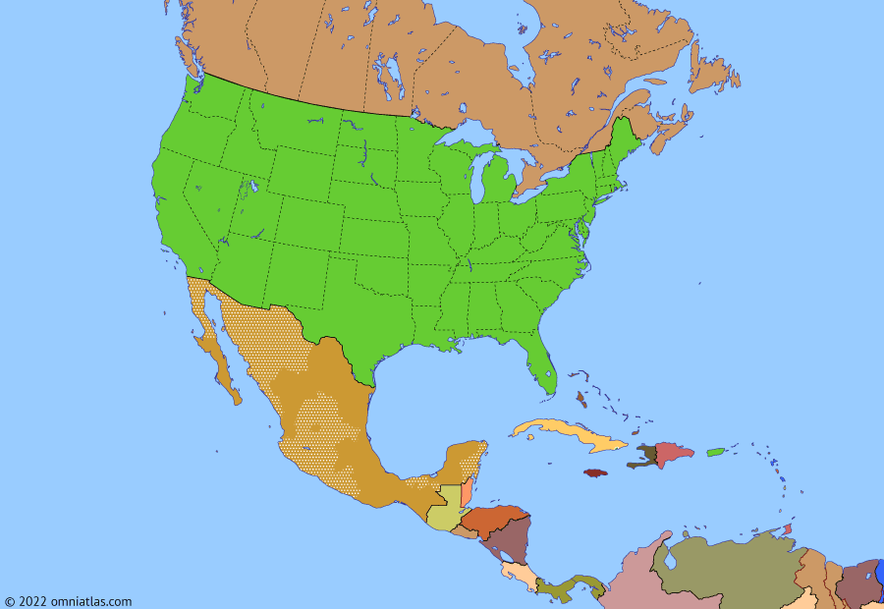

**RE: Encountering Humanism**

In this RE module, we will be focusing on Humanism. We will be exploring the non-religious worldview of Humanists and their possibilities of seeking a positive life without religion or belief. We will compare ideas with other religions, so your child is able to see the similarities and differences. A key concept we will be investigating is the idea of happiness.

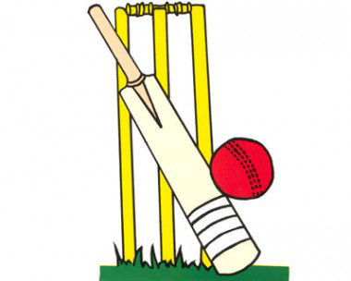

**See bespoke pathways for Maths and English**

**Computing: Invent a Product**

In this inventing a product unit, children will design a product. They will evaluate, adapt and debug code to make it suitable and efficient for their needs. We will use a software program to design their products and finally create their own websites and video adverts to promote their inventions.

**Music: Play and** alongside Classroom Jazz 1 and Production

This Unit of Work focuses on improvising. Using two great pieces, Three Note Bossa and Five Note Swing, the pupils will learn to play the pieces and then explore improvising with the repertoire.

**PSHE: Changing Me**

In this module, the children will be looking at how their own and others bodies will be changing. Children will be encouraged to have conversations about growing up and going through puberty, while also acknowledging other factors that impact their teenage years.

**Year 6**

**Summer 2**

**Art: Seascapes**

In this module, we will be continuing to develop our artistic skills. After previously looking at landscapes, the children can use the skills they learnt to create original and inspired seascape pieces. Artwork will be created in a variety of mediums with emphasis being placed on representing the sea as a number of moods.

**PE: Cricket and Hockey**

Year 6 will be developing a variety of skills in contrasting gams. Looking at the different aspects of cricket, the children will be exploring batting, bowling and fielding, modelling developments on prior knowledge learnt from rounders. After refining cricket skills and gaining an understanding of the rules, the children will be given the opportunity to display the skills they have learnt in game like situations. Hockey will be our second sport for this term, children will focus on keeping the ball under control. Children will be encouraged to dribble, pass and control the ball in isolation and game like situations.