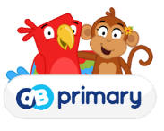[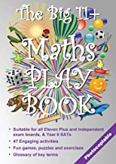](https://www.amazon.co.uk/gp/slredirect/picassoRedirect.html/ref=pa_sp_mtf_aps_sr_pg1_1?ie=UTF8&adId=A07029032XWMINP0VIWP&url=/Big-11-Maths-Play-Book/dp/1912936070/ref%3Dsr_1_11_sspa?dchild%3D1%26keywords%3Dmaths%2Bstories%26qid%3D1605095231%26sr%3D8-11-spons%26psc%3D1&qualifier=1605095231&id=4550806032619715&widgetName=sp_mtf)[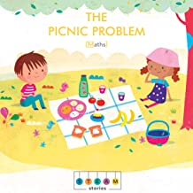](https://www.amazon.co.uk/STEAM-Stories-Picnic-Problem-Maths/dp/0711239878/ref=sr_1_8?dchild=1&keywords=maths+stories&qid=1605095231&sr=8-8)[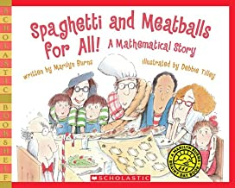](https://www.amazon.co.uk/Spaghetti-Meatballs-All-Scholastic-Bookshelf/dp/0545044456/ref=sr_1_5?dchild=1&keywords=maths+stories&qid=1605095231&sr=8-5)[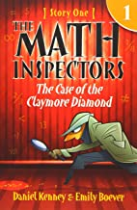](https://www.amazon.co.uk/Math-Inspectors-Story-Claymore-Diamond/dp/150313699X/ref=sr_1_4?dchild=1&keywords=maths+stories&qid=1605095231&sr=8-4)[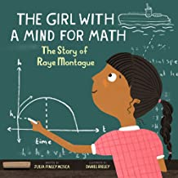](https://www.amazon.co.uk/Girl-Mind-Math-Montague-Scientists/dp/1943147426/ref=sr_1_3?dchild=1&keywords=maths+stories&qid=1605095231&sr=8-3)[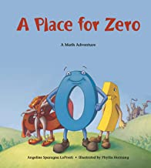](https://www.amazon.co.uk/Place-Zero-Adventure-Charlesbridge-Adventures/dp/1570911967/ref=sr_1_1?dchild=1&keywords=maths+stories&qid=1605095109&sr=8-1)

**Maths Selfies**

Maths is all around us! In fact, it’s unavoidable. With that in mind, we’d love to share photos of your children using maths in everyday life. We’re calling them Maths Selfies!

Please send in your Maths Selfies showing the children using maths outside of school and in everyday life. This could be counting money in a shop, measuring and weighing when cooking, measuring the length of something, or anything else you can think of to do with maths. Please email your maths selfie to:

[admin@woodley.suffolk.sch.uk](mailto:admin@woodley.suffolk.sch.uk)

or if your child is in KS2 then you could send it in via class dojo.

Welcome to this month’s Wood Ley Math’s newsletter.

Ages 9-12

Ages 4-6

Ages 4-8

Ages 9-12

Ages 5-8

Ages 6-9

**Books about maths**

**Home Learning Maths**

Curriculum Guides For Parents

As with teachers there’s a vast range in what parents already know about the primary maths curriculum and the crossover into secondary maths. Third Space Maths have created home learning toolkits as practical information guides to hand to parents and carers with children studying maths at school. Each one breaks down what the curriculum expects children to learn in maths for each year group and then how parents can help support their children through it.

Year 2 - <https://thirdspacelearning.com/blog/year-2-maths/>

Year 3 - <https://thirdspacelearning.com/blog/year-3-maths/>

Year 4 - <https://thirdspacelearning.com/blog/year-4-maths/>

Year 5 - <https://thirdspacelearning.com/blog/year-5-maths/>

Year 6 - <https://thirdspacelearning.com/blog/year-6-maths/>