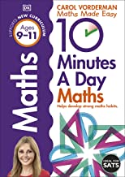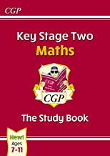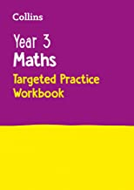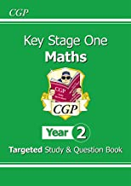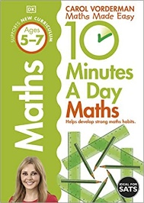

**Working on maths at home**

Welcome to this month’s Wood Ley Math’s newsletter.

This month’s focus: Words

**Maths Selfies**

Maths is all around us! In fact, it’s unavoidable. With that in mind, we’d love to share photos of your children using maths in everyday life. We’re calling them Maths Selfies!

Please send in your Maths Selfies showing the children using maths outside of school and in everyday life. This could be counting money in a shop, measuring and weighing when cooking, measuring the length of something, or anything else you can think of to do with maths. Please email your maths selfie to:

[admin@woodley.suffolk.sch.uk](mailto:admin@woodley.suffolk.sch.uk)

or if your child is in KS2 then you could send it in via class dojo.

Now you can also send them as a post on TEAMs too!

**The importance of language**

**When we think of words and vocabulary, we usually think of English lessons. Using ambitious words in our writing, developing our language skills further etc.**

**Maths vocabulary is equally as important.**

**What do all of the following words and phrases have in common?**

How many left, difference, subtract, difference between, takes, less than, lower than, decrease, different, off

**They are all words and phrases that mean ‘subtract’**

**This shows how important learning maths words is.**

**As a school we ensure that we use the correct mathematical language in our lessons and always look to teach the essential vocabulary your children will need to be successful at maths.**

