****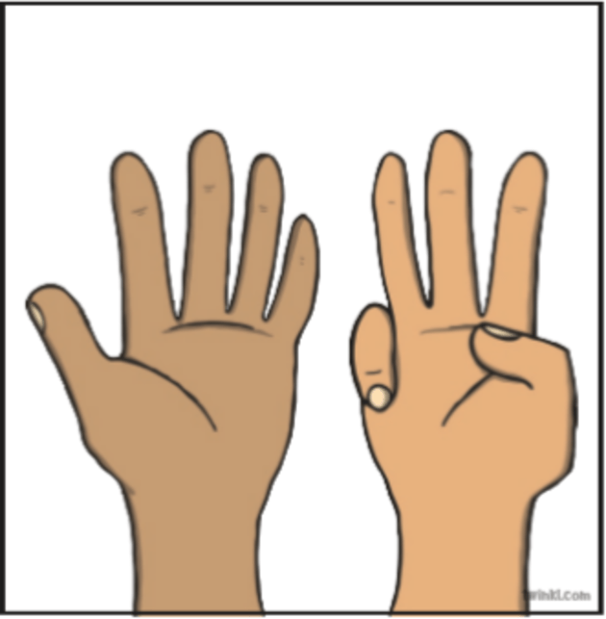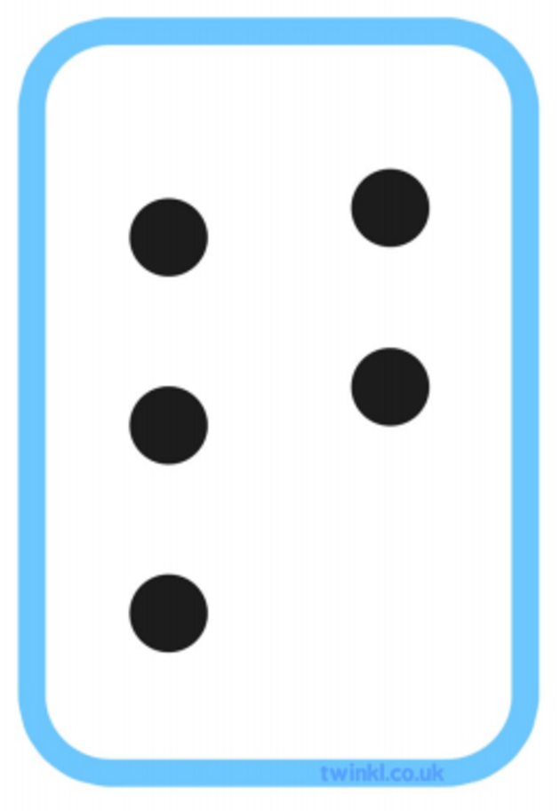

How can I help my child learn to subitise?

Using board games with dice is a fun way to develop children's subitising ability without them even realising.

Any practical counting activity is ideal. In particular, activities where children are shown a number and then have to build these numbers with counters, for example, are perfect.

It's all about exposing children to the visual representations of numbers.

Don’t forget to regularly get

your children practising times tables

on Times Table Rockstars!

How does subitising work?

When we're younger, our visual memory is very powerful. This makes it easier for us to remember images than it does words or numbers. This is how we begin to subitise.

By linking an image or visual representation of a number to the number itself, we're able to forge a lasting connection between the two.

This explains why we're able to link the image of 6 dots on a dice to the number 6 without counting.

**Why is be able to subitise useful?**

Simply, it can make working out maths problems a lot faster. If your brain is already able to recognise certain groups of numbers easily, then you'll have more time to focus on other aspects of the problem.

We also subitise in our everyday lives. For example, you might be subitising without realising when you pick out 3 20p coins to pay for something that costs 60p.

This month the newsletter is all about ‘subitising’ and how it can help early mathematicians.

Stop counting!

What is subitising?

Subitising is when you are able to look at a group of objects and realise how many there are without counting. This only works with small groups of numbers, as we can only subitise up to 5 things. It was first introduced by a Swiss psychologist called Piaget.

Types of subitising

**Perceptual subitising**

This is the ability to recognise the number of objects in front of you without using any mathematical process - it's instinctual.

**Conceptual subitising**

This is where you are able to recognise a number by grouping in into small sets. For example, if you are shown a line of 6 black dots, it's likely that you will automatically group these into 2 groups of 3, and then know that there are 6 in total without actually counting each one.

Welcome to this month’s Wood Ley Math’s newsletter.

For those of you who are new to the school, we produce a maths newsletter, which hopefully gives you helpful ideas to support the learning of maths at home as well as sharing some of the maths we do in school.