**History: Egypt**

* In this Ancient Egyptian unit, the students will be taught about the achievements of this ancient civilisation. They will learn about how and where the ancient Egyptians lived, what was important to the daily lives of ancient Egyptians, who Tutankhamun was and how mummies were made. The children will also learn about how Egyptian people used hieroglyphs to communicate and compare the powers of different gods. All children should be able to:
* Understand what was important to people during ancient Egyptian times.
* Compare the powers of different Egyptian gods.
* Find Egypt on a map.
* Raise questions when confronted with an artefact in order to understand more about this ancient civilisation and select information that is useful in understanding the use of hieroglyphs as a form of communication and recording.

• Know where and when the Egyptians lived through looking at maps and artefacts.

• Select information about mummification and Egyptian gods carefully when learning about these areas.

Some children will be able to:

• Address and sometimes devise historically valid questions about change, cause, similarity by learning about the daily lives of many ancient Egyptian people.

• Construct informed responses that involve thoughtful selection and organisation of relevant historical information.

• Understand how evidence can give us different answers about the discovery of Tutankhamun's tomb, noting connections, contrasts and trends over time.

• Develop the appropriate use of historical terms such as 'BC/AD', 'civilisation' and 'artefact

**Science: Properties of Materials**

The students will be planning different types of scientific enquiries to answer questions, including recognising and controlling variables where necessary. They will be reporting and presenting findings from enquiries, including conclusions, causal relationships and explanations of and degree of trust in results, in oral and written forms such as displays and other presentations. They will compare and group together everyday materials on the basis of their properties, including their hardness, solubility, transparency, conductivity (electrical and thermal), and response to magnets. After experimenting, they will know that some materials will dissolve in liquid to form a solution, and describe how to recover a substance from a solution. They will use knowledge of solids, liquids and gases to decide how mixtures might be separated, including through filtering, sieving and evaporating. After investigating, they will give reasons, based on evidence from comparative and fair tests, for the particular uses of everyday materials, including metals, wood and plastic. The students will demonstrate that dissolving, mixing and changes of state are reversible changes. They should be able to explain that some changes result in the formation of new materials, and that this kind of change is not usually reversible, including changes associated with burning and the action of acid on bicarbonate of soda

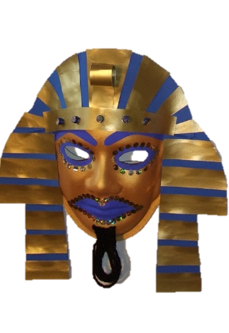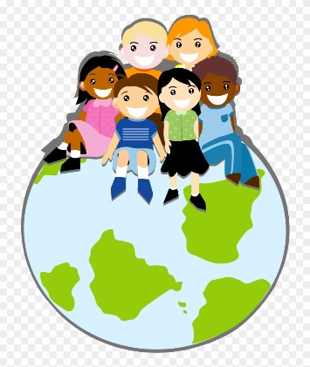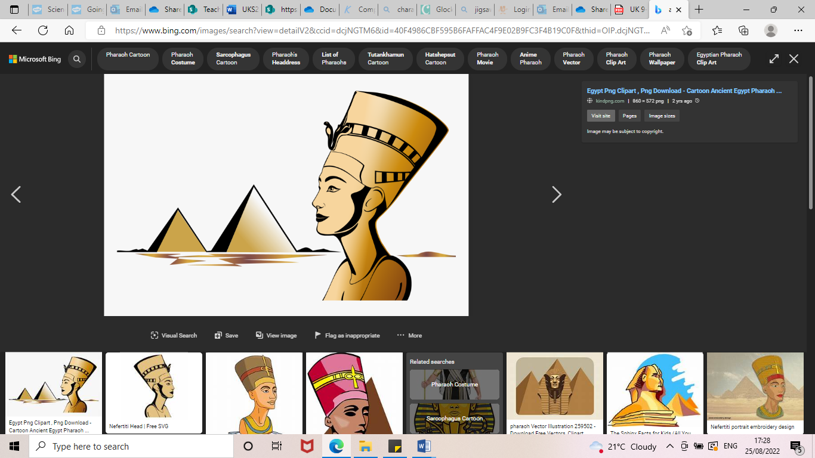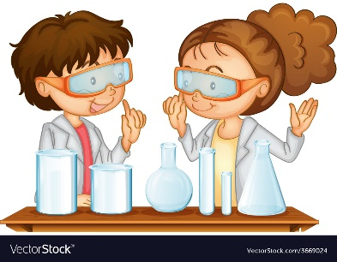

**See bespoke pathways for Maths and English**

**Computing: Online Safety**

After studying this unit, pupils who are secure will be able to:

Understand that passwords need to be strong and that apps require some form of passwords. Recognise a couple of the different types of online communication and know who to go to if they need help with any communication matters online. They will search for simple information about a person, such as their birthday or key life moments. They will know what bullying is and that it can occur both online and in the real world. The students will recognise when health and wellbeing are being affected in either a positive or negative way through online use. Students will be able to offer a couple of advice tips to combat the negative effects of online use.

**PE: Swimming**

This should include teaching pupils to:

* Swim competently, confidently and proficiently over a distance of at least 25 metres
* Use a range of strokes effectively – for example, front crawl, backstroke and breaststroke
* Perform safe self-rescue in different water-based situations

**Egyptian Dance**

Pupils will be creating and performing dances using a range of movement patterns, including those from different times, places, and cultures.

**PSHE: Being Me in My World**

Within this unit, the children will explore their role, responsibilities and rights as a citizen of both the UK and their classroom. They will understand how democracy and having a voice benefits the school community and know how to participate in this. They will realise how their behaviour can impact other people.

**Art/DT: Egyptian Masks**

The children will be constructing their own Egyptian masks using a variety of materials. After studying photos of artefacts, they will create their own Canopic jar from clay. The pupils will be encouraged to sketch their designs prior to construction.

**French: Getting to Know You**

In this unit, the children will apply previous skills and knowledge of topic areas such as spelling and jobs. They will have a chance to recap previous tasks from LKS2. They will learn to express their emotions and talk about the future, using two different tenses. They will talk about what they would like to do in the future and will have the opportunity to explore story books written in French to make links between what they are learning now and what they have learnt in the past. The children will explore why MFL are important and will be taught that French is spoken in 29 countries around the world.

**RE: Beliefs and Questions: Christianity**

The children will be exploring the theme of incarnation**.** Incarnation is the traditional Christian belief that God came into the world in human flesh in the person of Jesus Christ. The first Christians believed Jesus was more than just a good man, healer, teacher or prophet but trying to put into words what they had experienced of this incredible man was like trying to catch the wind. Eventually they expressed their belief by stating that Jesus was both fully human and fully God (divine). Students will be exploring Christianity through the theme of Incarnation.

**Year 5**

**Autumn 1**

**Music: Glockenspiels**

The learning this term is focused around exploring and developing playing skills through the glockenspiel. The children will build on their understanding of the language of music and notation.