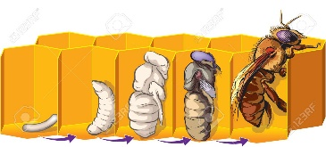

**History: Stone Age**

In this unit, the children will:

* compare and contrast a society in the past with my own and contribute to a discussion of the similarities and differences.
* discuss why people and events from a particular time in the past were important, placing them within an historical sequence
* interpret historical evidence from a range of periods to help to build a picture of Scotland’s heritage and my sense of chronology.
* investigate a Scottish historical theme to discover how past events or the actions of individuals or groups have shaped Scottish society.
* use primary and secondary sources selectively to research events in the past.
* construct informed responses that involve thoughtful selection and organisation of relevant historical information by learning about how early man survived in the Stone Age.
* regularly address and sometimes devise historically valid questions about change, cause, similarity and difference, and significance by learning about Skara Brae and understanding its significance in knowing more about the Stone Age.
* continue to develop a chronologically secure knowledge and understanding of British, local and world history, establishing clear narratives within and across the periods they study by learning about what happened in the Bronze Age, looking at how copper mining was crucial to the people of this time.
* understand how our knowledge of the past is constructed from a range of sources and that different versions of past events may exist, giving some reasons for this by learning the different theories for the building of Stonehenge.
* note connections, contrasts and trends over time and develop the appropriate use of historical terms by learning how and why hillforts developed as popular places to live in the Iron Age.
* understand how our knowledge of the past is constructed from a range of sources and that different versions of past events may exist, giving some reasons for this by understanding why some of our knowledge about Iron Age Druids could be unreliable.

**Science: Life Cycles of Plants and Animals**

In this unit, the children will:

* recap the names of parts of a flower and learn about how flowering plants reproduce sexually. They will then either label diagrams of flowering plants or dissect flowers.
* learn about some ways in which nonflowering plants reproduce asexually, then either describe one of these processes in their own words or grow plants from cuttings.
* learn about sexual reproduction in animals, including some ways in which some reptiles and fish reproduce. They will then either sort and classify animals or compare their life expectancies and gestation periods.
* study and compare the life cycles of animals living in a variety of environments. They will then either research animals living in different environments or compare the life cycles of two animals living in different environments.
* learn more about the life cycles of animals, focussing on gestation periods and growth. They will then explain the life cycles of animals in their own words, using technical vocabulary.
* learn about the work of naturalists and animal behaviourists, then research and write indepth about a well-known naturalist.

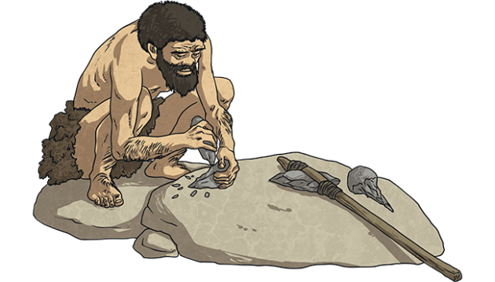

**See bespoke pathways for Maths and English**

**Year 5**

**Summer 1**

**French: School life**

In this unit, the children will:

* understand basic grammar rules appropriate to the language being studied, how to apply these, for instance, to build sentences in the context of saying where characters are standing in the classroom
* read carefully and show understanding of words, phrases and simple writing in the context of describing the positions of objects
* speak in sentences, using familiar vocabulary, phrases and basic language structures in the context of subjects studied at school
* understand basic grammar appropriate to the language being studied, how to apply these, for instance, to build sentences in the context of subjects studied at school
* engage in conversations; ask and answer questions in the context of a Maths/French lesson
* engage in conversations; ask and answer questions in the context of asking and answering questions about what can be done
* present ideas and information orally to a range of audiences in the context of asking questions which they would ask in school

**PSHE: Relationships (RSE)**

In this unit, the children will:

* have an accurate picture of who I am as a person in terms of my characteristics and personal qualities
* understand that belonging to an online community can have positive and negative consequences
* understand there are rights and responsibilities in an online community or social network
* know there are rights and responsibilities when playing a game online
* recognise when I am spending too much time using devices (screen time)
* explain how to stay safe when using technology to communicate with my friends

**Art/DT: Wire Sculpture and Painting**

The children will make a Stone Age sculpture using metal in the style of Alberto Giacometti.

The children will create Stone Age cave paintings.

**PE: Athletics**

The children will:

* be able to apply different speeds over varying distances
* develop fluency and co-ordination when running for speed
* develop technique in relay changeovers
* develop technique and co-ordination in the triple jump
* develop throwing with force for longer distances
* develop throwing with greater control and technique

**Rounders**

The children will:

* develop the bowling action and understand the role of the bowler
* develop batting technique
* make decisions about where and when to send the ball to stump a batter out
* develop a variety of fielding techniques and when to use them in a game
* develop long and short barriers in fielding and understand when to use them

**Computing: Creating Media – Stop Motion Animation**

In this unit, the children will:

* Create a toy with simple images with a single movement.
* Create a short stop motion with small changes between images.
* Think of a simple story idea for their animation then decompose it into smaller parts to create a storyboard with simple characters.
* Make small changes to the models to ensure a smooth animation and delete unnecessary frames.
* Add effects such as extending parts and titles.
* Provide helpful feedback to other groups about their animations.

**RE: Christianity – Journey of Life and Death**

The children will:

* Explain how believers have expressed their religious beliefs (ideas, feelings, etc) in a range of styles and words, and suggest reasons for this
* Use the right religious words to describe practices and experiences which may be involved in Christianity
* Express religious beliefs (ideas, feelings, etc) in a range of styles and words used by believers and explain what they are trying to convey
* Ask questions about the diversity of groups people belong to, and suggest answers which refer to people’s heritage, background, choices or beliefs

**Music: The Fresh Prince of Bel Air (Charanga)**

In this unit, the children will know:

* the style indicators of the song
* the structure of the song
* how some of the dimensions of the music fits together in the song
* the historical context of the song

They will sing the song and play the glockenspiel during the instrumental parts.