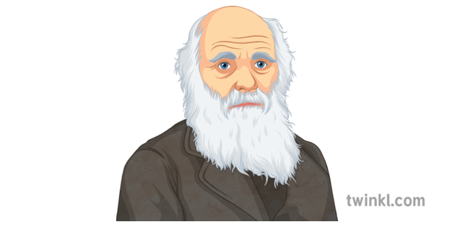

**Geography: Europe**

In this unit, the children will be learning all about Eastern Europe and our resources are here to support you along the way. Firstly, they will learn about the countries of Europe. They will then look in more detail at some of the contrasting areas of Eastern Europe, finding out about the landscape, climate and locations in each area. Children will bring together their learning about one area of Eastern Europe and create information booklets to share what they have found out. In the final lesson of the unit, children will find out more about Chernobyl and its impact on Eastern Europe and the rest of the world.

**Science: Evolution**

1. The children *will learn about inheritance and will be able to recognise that living things produce offspring of the same kind, but normally offspring vary and are not identical to their parents. Pupils will recognise how animals and plants are adapted to suit their environment in different ways and that adaptation can lead to evolution. The children will recognise the fact that some people are creationists and that the Theory of Evolution might juxtapose the beliefs of some religious communities. They will discover the work of Charles Darwin and recognise the fact that Al Jahiz made similar discoveries in Iraq 1,000 years before Darwin. The children will realise that fossils provide information about living things that inhabited the Earth millions of years ago. The children will be encouraged to think scientifically. The children will learn about DNA and they will make links between the knowledge obtained during their Stone Age History topic.*

**Year 6**

**Autumn 2**

**PE: Badminton and Yoga**

Yoga- The aim of this unit is to introduce the idea of **yoga** as a means to focus on oneself, to learn some basic poses and relaxation techniques.

Badminton- We are learning how to play forehand and backhand shots to multiple targets.

**Computing: Python Programming**

The pupils will explore a new piece of software. They will iterate ideas, testing and changing throughout the lesson and explain what their program does. They will alter the house drawing using Python commands and use comments to show a level of understanding around what their code does. They will Use loops in Python and explain what the parts of a loop do. After this, they will recognise that computers can choose random numbers; decompose the program into an algorithm and modify a program to personalise it.

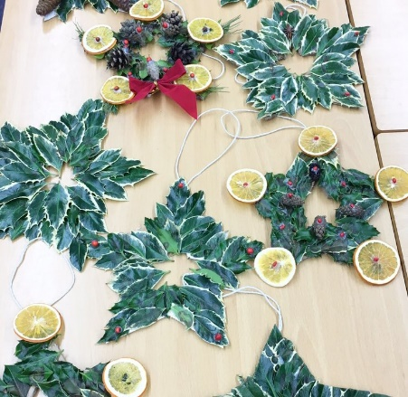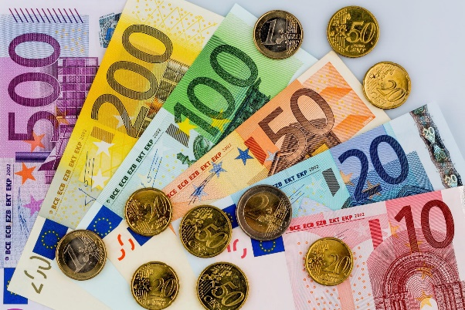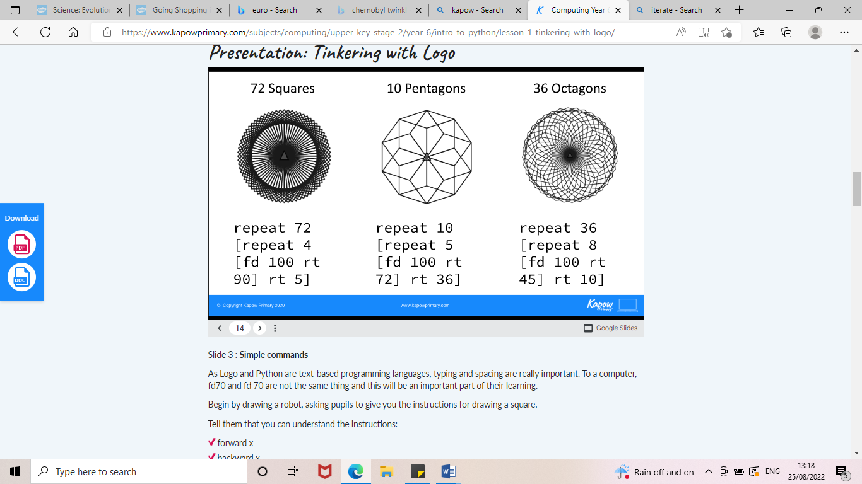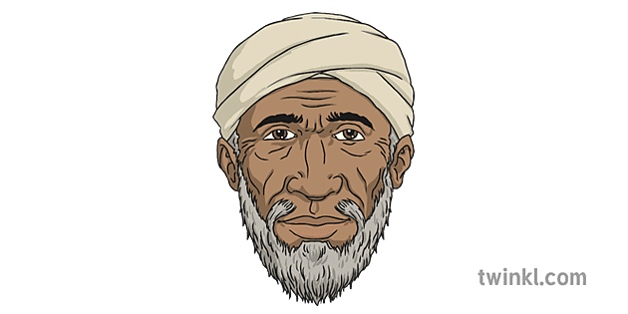

**See bespoke pathways for Maths and English**

**Music: Christmas Show preparation**

The children will be learning songs for our ‘Christmas by Candlelight’ performance which we will invite guardians to watch.



**PSHE: Celebrating Difference**

Within this unit, the children will be discussing the word ‘normal’. They will be encouraged to show empathy towards different groups of people. We will be discussing persecution and strategies will be provided for children to use in the event of uncomfortable situations which may occur in their futures including bullying. The children will understand that diversity is a strength of our community.

**Art/DT: Enterprise**

During this self-funding project, the children will create products and crafts to sell during their enterprise. All children will take part in a floristry wreath making activity and foods inspired by Christmas throughout Europe.

**European Christmas food making**

**French: Let’s Go Shopping!**

In this ‘Let's Go Shopping’ unit, the children will learn about the shopping experience in France. Children will learn how to use the nuances of colour when describing the colours of clothes and how to use prepositional language. They will learn key phrases for asking the questions needed when going shopping. The unit concludes with a role play lesson, where children will take on the roles of shoppers and shopkeepers.

The children will have opportunities to explore the culture of other French-speaking countries.

**RE: Gospels (Christianity)**

The gospels relate the stories and teachings ofJesus of Nazareth; they are not biographies but accounts to help different groups of Christians understand who Jesus was and what he did. They include well-known stories, parables, and sermons, e.g. Jesus' birth in Bethlehem, Sermon on the Mount, Beatitudes, Last Supper, and the Great Commission. The children will understand that the word ‘gospel’ means good news- they will explore how this word is used in sacred and secular contexts.